**Steps to Create an Alert for VM Deletion:**

1. **Go to Azure Portal**:
   * Navigate to the [Azure Portal](https://portal.azure.com).
2. **Navigate to Azure Monitor**:
   * In the left-hand menu, search for and select **Monitor**.
3. **Create a New Alert Rule**:
   * In Azure Monitor, select **Alerts** > **+ New Alert Rule**.
4. **Select the Resource**:
   * In the **Scope** section, click **Select Resource**.
   * Search for the subscription or resource group where your VM exists.
   * Select the resource group or subscription as your scope (so the alert applies even if the VM is deleted).

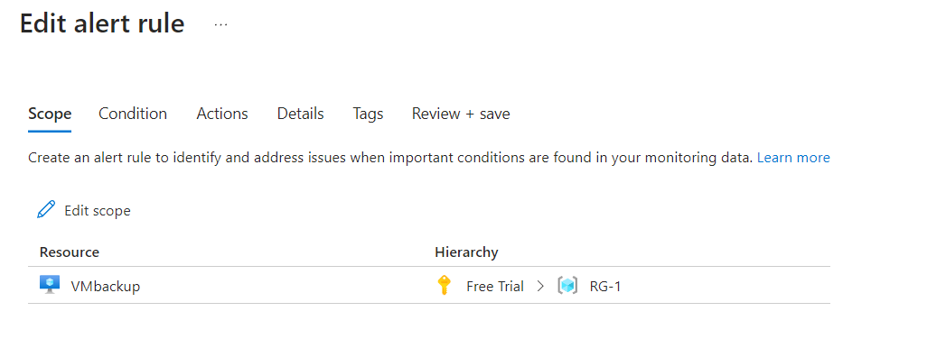

1. **Set the Condition**:
   * In the **Condition** section, click **Add Condition**.
   * In the search bar, type **Activity Log** and select **Delete Virtual Machine (Microsoft.Compute/virtualMachines/delete)** from the available signals.
   * This will create a condition based on the deletion of any virtual machine.

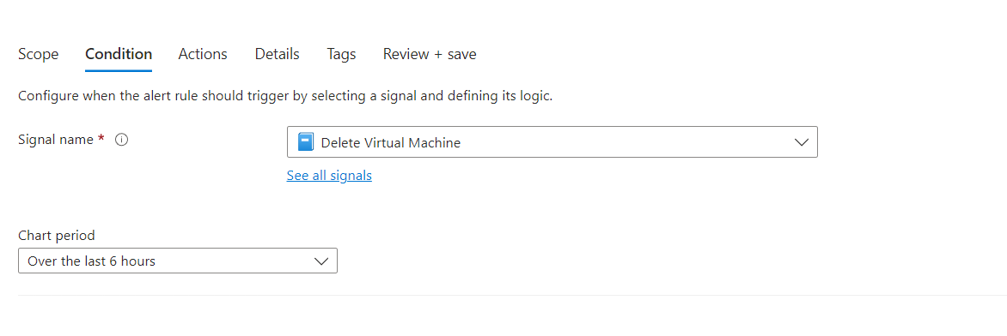

1. **Set the Action Group**:
   * In the **Actions** section, click **Add action group**.
   * Either create a new action group or select an existing one. Action groups define what happens when the alert is triggered, such as sending an email, SMS, or invoking a webhook.
   * If you need to create a new action group, configure the notification type (email, SMS, push notifications) and provide the required details.

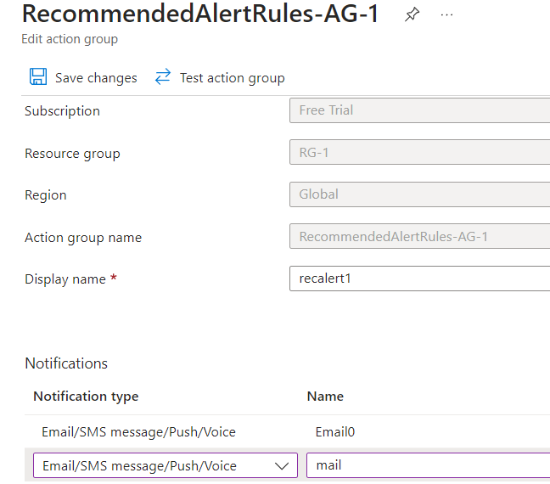

1. **Define Alert Details**:
   * In the **Details** section, give your alert a **name** ( Delete").
2. **Review and Create**:
   * Review the alert settings.
   * Click **Create**.

